CITY DEAL EXECUTIVE AND STEWARDSHIP BOARD

Private and Confidential: No

Monday, 18 September 2017

Implementation Update - Quarter 1 - April - June 2017
(Appendices 'A', 'B' and 'C' refer)

Report Author: Sarah Parry, Programme Manager – City Deal, Lancashire County Council, 01772 530615, email sarah.parry@lancashire.gov.uk
Jo Ainsworth, Finance Advisor, Lancashire County Council, 01772 532358, email joanne.ainsworth@lancashire.gov.uk

Executive Summary

This report provides a progress update on delivering the infrastructure schemes during Quarter 1; April-June 2017 and sets out the latest position going forward. The report is presented in 3 parts:-
- Quarter 1 Project Monitoring Report - Dashboard and detailed analysis attached
- Update on Implementation Issues
- Quarter 1 - Finance Monitoring Report

Recommendation

The City Deal Executive and Stewardship Board is asked to note the Quarter 1 Implementation Update for the period April-June 2017.

Background and Advice

1. QUARTER 1 – PROJECT MONITORING REPORT (Apr-Jun 2017)
1.1 Current Position

1.2 A quarter 1 performance dashboard is attached at Appendix 'A' and provides "at a glance" information on the delivery of the infrastructure schemes to date. The more detailed project monitoring analysis for quarter 1 is also attached at Appendix 'B' for those requiring more information on the specific schemes.

It can be noted from the appendices, that there were a small number of schemes with specific milestones in the period April-Jun (quarter 1). The report confirms that all but one of those were achieved including completion of improvement works on Cannon Street, Preston. The milestone not achieved in quarter 1, related to the completion of the feasibility study for the proposed Ribble Crossing, which is now expected in quarter 2.

1.4 The Executive and Stewardship Board will note that of the 49 infrastructure schemes included in the Plan for 2017/18; 22 are progressing as planned with no issues identified; 8 have been highlighted amber due to potential risks of not meeting milestones going forward; 2 have been highlighted red due to the potential risk to delivery being high; 6 schemes have now completed and 11 schemes are under review/subject to the outcome of masterplanning exercises and therefore no milestones have been agreed at this point in time.

1.5 The monitoring spreadsheet also highlights some movements in programme delivery timescales which will be updated in the Business and Delivery Plan as follows:-

Highways and Transport/Priority Corridors
- Broughton Bypass – early completion in Q3 ahead of forecast completion in Q4.
- Penwortham Bypass – Planning Application being determined in Q2 due to the requirement to respond to technical representations to the planning application.
- New Ribble Crossing Feasibility Study – Study will now complete in Q2 as opposed to Q1, due to technical details which require more analysis than anticipated.
- Bamber Bridge – Following the detailed design process, phase 2 of the scheme is now expected to complete in Q1 2018/19.
- Cuerden Strategic Site Road Infrastructure – Planning application now due to be determined in Q2 due to additional information being required.

Community Infrastructure

- Lancaster Canal Towpath – scheme to be reprogrammed due to a financial challenge with anticipated costs above the fixed s.106 sum allocated.
- Tom Benson Way – scheme to be reprogrammed due to ecological matters arising that need to be resolved.
- Youth Zone – The scheme will not commence on site in Q2 due to officers exploring how additional LCC services can be accommodated in the new building. The scheme will need to be reprogrammed.
- Guild Wheel Upgrade – Bluebell Way – Design approval now scheduled for Q2, due to further information about the scheme funding position and design constraints being requested by the Infrastructure Delivery Steering Group.
- Guild Wheel Upgrade – Watery Lane - Design approval now scheduled for Q2, due to further information about the scheme funding position and design constraints being requested by the Infrastructure Delivery Steering Group.

2. UPDATE ON IMPLEMENTATION ISSUES

2.1 Current Position

2.2 The table below sets out the more significant issues that are being prioritised in the Programme in order to appropriately manage risk. Some of the issues have previously been reported and an update on the current position is provided.

Scheme/Issue | Update/Latest Position
Preston Western Distributor | See separate report on agenda.
East/West Link Road | See separate report on agenda.
Pickerings Farm - Link Road cannot be progressed to design stage until bridge options have been determined and funding issues resolved.  Arrangements will need to be in place prior to detailed masterplanning being completed. | Discussions are ongoing with Network Rail regarding a new bridge over the WCML and the associated cost implications for the City Deal. Further work is being undertaken to understand at what point this access is required from a highways technical perspective. A contract for the design of Bee Lane Bridge has now been agreed with Network Rail and they will undertake this specialist design work.  Negotiations with Taylor Wimpey over a Collaboration Agreement are ongoing. It is anticipated that this agreement will be finalised by October 2017. It is expected that consultants will be procured by February 2018. The planning application is programmed to be submitted in Q4 Year 5.
Croston Road Spine Road – Land acquisition relating to the delivery of the full spine road is more complex than originally anticipated and have not yet concluded. | The HCA will now oversee the delivery of the Spine road as part of the wider development. Issue closed.
Fishergate Phase 3 | See separate report on agenda.

3. YEAR 4, QUARTER 1 FINANCE MONITORING REPORT (attached)

3.1 Introduction

3.2 The City Deal infrastructure delivery model ("the model") is a finance model showing the finance activity to date and expected within the City Deal. The model is split into two sections - resources being income to be received into the model from the various income streams and delivery programmes being expenditure paid or forecast to be paid on the infrastructure schemes. The City Deal is an accelerated delivery model based on the understanding that while the timing of resources coming into the model will be behind expenditure on schemes, requiring cash flow support from the County Council, there is a commitment of the partners to keep the model balanced.

3.3 It is recognised that the model is dynamic and that changes to the inputs and outputs of the model will occur over time. This is sustainable subject to maximum cash flow approvals being in place and not being breached.

3.4 Key risks to the model

Resources

3.5 Whilst most of the income to the model is fixed in commitment or capped amounts, the main risk (with the exclusion of changes to Government policy and how those might affect the model, which are being considered by the City Deal Executive and Stewardship Board) to the model in terms of income, is certainty of securing developer contributions in line with the expectations at the outset of the City Deal as noted above.

3.6 The total of these in the current model is £106.842m after building in increased rates and the modelling of those sites / units which will attract CIL and other contributions. Following interim findings of the Resources Review, undertaken by external consultants, £11.976m of this is now expected to come into the model in the “run-on” period of years 11-15, due to reported slippage in sites being brought forward for development. This also has an impact on the period of time that LCC will have to cash flow the City Deal over and the resulting finance charges incurred.

3.7 While there is more certainty with regard to the CIL element of developer contributions, within this total figure of £106.842m there is also £52.945m which relates to “other developer contributions”, sometimes referred to as CIL Plus, and which includes monies payable through, for example, section 106/ 278 agreements. It should be noted that to date £34.804m of these have already been secured leaving an amount of £18.033m still to be sought. This represents a risk to the model remaining in balance as should these not be secured, expenditure and resource forecasts will not remain aligned. The issues relating to the agreed s106/s278 monies and the linking to delivery of schemes is addressed below and is the subject of ongoing work.

3.8 There are also changes to government policies proposed relating to CIL, NHB and business rates along with a housing white paper – all of which have the potential to undermine the assumptions currently in the model. These have been considered in the Resources Review work. To date only the NHB changes have been confirmed. In short the changes are from 2018/19 for NHB being paid for 4 years instead of 6 per house. The impact on the current 10 year model would be circa £9m with no mitigation. Over a 15 year period with the NHB reduction, the model would continue to be adversely impacted.

Expenditure

  - All agreed expenditure changes and slippages have been included in the model and items to be agreed at this meeting will be reflected in future models once agreed.

  - The Executive and Stewardship Board considered, at its June 2017 meeting, a report outlining current estimates for PWD and EWLR and a report on this item appears elsewhere on this agenda. The current IDF position does not reflect revised PWD cost estimates.

  - Scheme estimates set out in the model continue to be refined and tested as schemes are subject to detailed design, preparation of cost estimates and tendering prior to implementation. The Infrastructure Delivery Steering Group has a process in place to ensure that final costs are scrutinised prior to approval and schemes are fully funded prior to implementation.

  - It should be noted that the expenditure lines are indicative budget allocations only – the amount needed and available for each scheme as it comes forward will depend on the dynamics of the model at the time in terms of funding secured and expected, along with competing priorities from other schemes.

  - Position of the model as at 30th June 2017

  - The model as at Quarter 1 2017-18 is attached at Appendix 'C' to this report.

  - The model is currently showing a projected surplus over the city deal period of £0.126m, compared to a position at year end 2016-17 of £2.634m.

  - All the changes to income relate to changes in the forecasts in housing numbers and known income from a site being more than was anticipated from that site following planning approval.

  - The major change to expenditure was the agreed commitment to additional funding of Broughton Bypass of £4.44m at the last meeting of the Executive.

  - The updated forecast outturn for 2017/18 compared against the forecast in the business plan 2017-20 is shown in the graphs below. However these are subject to change following the completion of work as detailed in the 2017/18 Resources table below.
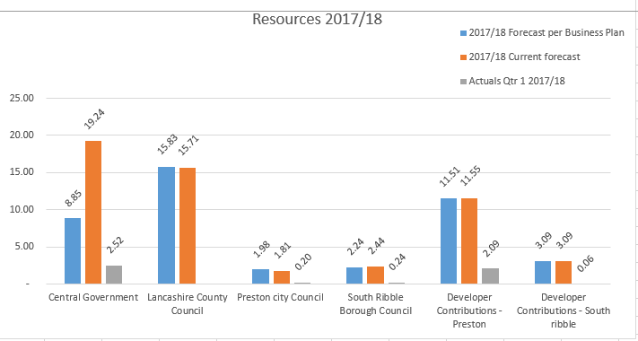

Nb. Central Government resources estimated in 2017/18 are higher than originally estimated due to the management of growth deal payments within city deal following slippages in the overall Growth Deal programme (funds are agreed with Government to be temporarily moved to non growth deal capital projects until required by original projects). This will mean reduced funding in future years to remain at the total agreed amount in City Deal over the period.

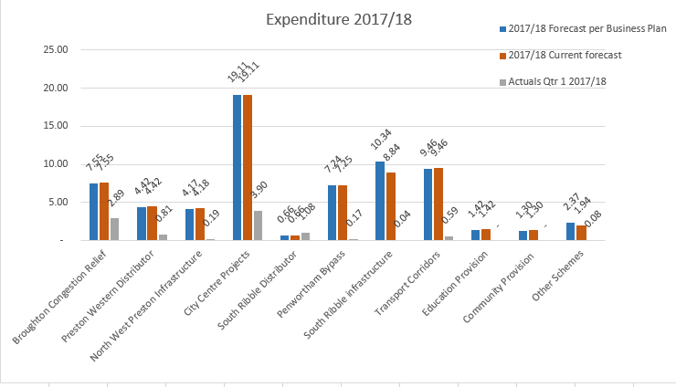

  - Key issues raised by 30th June 2017

  - As part of the Resources Review, Keppie Massie are advising on the assumptions made at the outset of the Deal with specific regard to the “other developer contributions” stream which includes s106 payments. Furthermore the councils continue to work together to ensure there is a shared and common interpretation of the binding Heads of Terms which require the partners to maximise the value of developer contributions being collected and paid into the fund. Work is underway to quantify the amount of additional developer contributions collected to date against that forecast as well as capture the projects being delivered by the funding, as part of the City Deal Infrastructure Delivery Plan.

